
h

Local Ai & Web Interface Lab
Prepared by Period 1-2  Gio Hua |  | 10/7/2025

Purpose:
The goal is to build two different Local AI engines that run completely on your CCNP desktop. There are many different options for running AI on Windows. One option is to use programs like LM Studio or Ollama. For the second model you need to develop a web UI so you can log in from other devices through a web interface.

Background:
Traditional artificial intelligence systems relied on cloud-based resources, but newer technologies made it possible to run these systems on local hardware. Cloud AI utilizes external servers to function, which allows for advanced decision making and high performance. It is capable of specific functions that simplify and speed up common business practices. Cloud AI is extremely versatile and is leveraged by many industries. Some of its uses include analyzing customer behavior for e-commerce applications and medical imaging analysis and patient care for healthcare companies. Additional advantages include large dataset processing, accessibility, cost effectiveness for training, and ease of implementation. In terms of large dataset processing, Cloud AI supports the ability to simultaneously run multiple models in the cloud without having to invest in significant computational power. along with the handling of large datasets. For accessibility, Cloud AI is globally accessible, allowing company teams from across the world to work together. Next, training can be made more efficient and cost-effective. Finally, for ease of implementation, many cloud AI models are pre-built and can be immediately implemented and utilized.
Some of the concerns for cloud AI include data privacy risks, latency issues, scalability issues, and ongoing costs. Since most models which provide for industries like finance and healthcare run on third-party servers, there are risks when uploading sensitive or personal data. Furthermore, reliance on remote servers may introduce delays. Growing network size and data transaction volumes means that scaling is necessary. Recurring expenses from data storage and transfer may prove cost to be a problem.
While cloud AI struggles to scale and secure data, local AI, on the other hand, does not have this problem. Local AI enlists systems that process data and execute models directly on local devices, such as smartphones or laptops. For those who prefer a privacy-first approach, local AI protects your data by processing information directly on site, therefore reducing exposure to breaches and eliminating the factor of third party providers. Additionally, since it runs on the local network, performance may improve (low latency). Fees can be avoided, and businesses have full ownership over their AI models, giving them flexibility and control.
Docker is a set of platform as a service products that uses operation-system-level virtualization to bring software in packages called containers. Deployment of applications are automated within lightweight containers, creating versatility and consistency throughout different computing environments. It was released in 2013, and continues to be developed by Docker, Inc..

Lab summary:
In this lab, Docker was used to create an isolated environment for running AI and machine-learning experiments. The first step was installing Docker and pulling the required container image, which provided a preconfigured workspace. Once the container was running, commands were put into Windows PowerShell in order to set it up the AI and WebUI. Thus, the AI Web interface is accessible on the local network. By using Docker, this lab demonstrates how containerization ensures consistency across different systems and prevents software errors.

Lab Commands:

1. Setting Up the Local AI Engine (Ollama)
Step 1 — Verify Existing Containers
docker ps -a
Step 2 — Create the Ollama Container
docker run -d --name lucid -p 11500:11434 ollama/ollama
Step 3 — Start the Ollama Container
docker start lucid
Step 4 — Verify the Container is Running
docker ps
Step 5 — Access the Container Shell
docker exec -it lucid bash
Step 6 — Run the Llama 2 Model
docker exec -it lucid ollama run llama2
# or
ollama run llama2

2. Setting Up the Open WebUI (Web Interface)
Run the following command in PowerShell to start the web interface:
docker run -d -p 3000:8080 --name open-webui ghcr.io/open-webui/open-webui:main
Verify the container is running:
docker ps

3. Accessing the Web Interface
Run the following command to identify your local IPv4 address:
ipconfig
Access the WebUI from any device on the same network using the following URL:
http://<Your-IPv4-Address>:3000

4. Verification & Testing
To confirm full integration:
1. Open the Open WebUI interface.
2. Select or add a model (e.g., llama2).
3. Run a short test prompt to verify connectivity and model response.

5. Troubleshooting Tips
Issue | Possible Cause | Solution
Container not listed in docker ps | Container not started | Run docker start <container_name>
Port conflict | Another service using same port | Change local port in the -p flag
Cannot access WebUI | Firewall or incorrect IP | Allow Docker through firewall / check IPv4 address
Model not responding | Ollama not linked or not running | Ensure ollama container is active and reachable

Configurations:
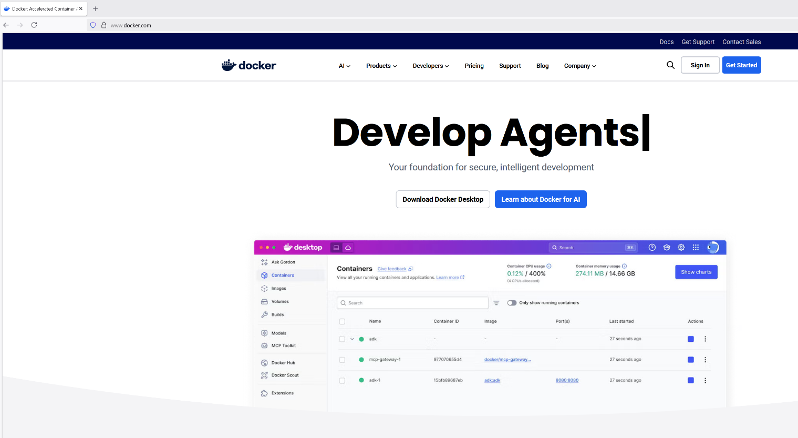
Go on https://www.docker.com/ and download docker for desktop
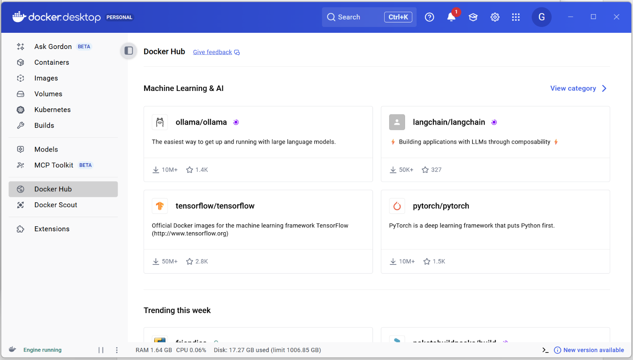
Run docker. Create account and sign in. Click Docker Hub. Click model of choice (ollama is used for this example)
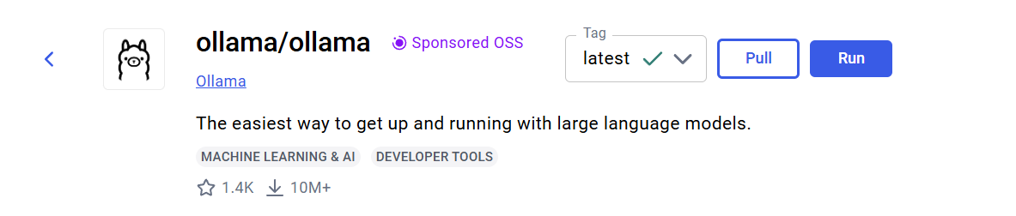
Click Pull. Then click Run. You will encounter the following prompt:
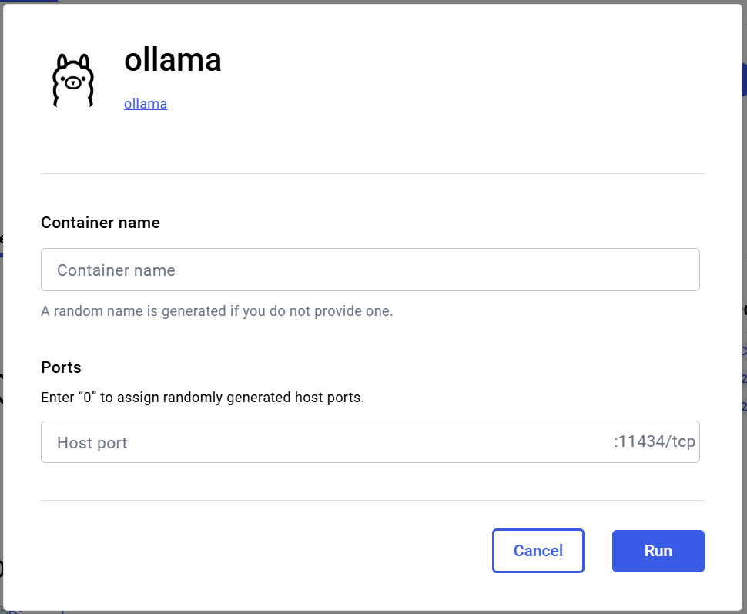
Give it a name (Lucid). Then assign it a host port (11500 in this example)

Into Powershell:
docker run -d --name lucid -p 11500:11434 ollama/ollama
docker start lucid
docker exec -it lucid bash
docker exec -it lucid ollama run llama2
docker run -d -p 3000:8080 --name open-webui ghcr.io/open-webui/open-webui:main
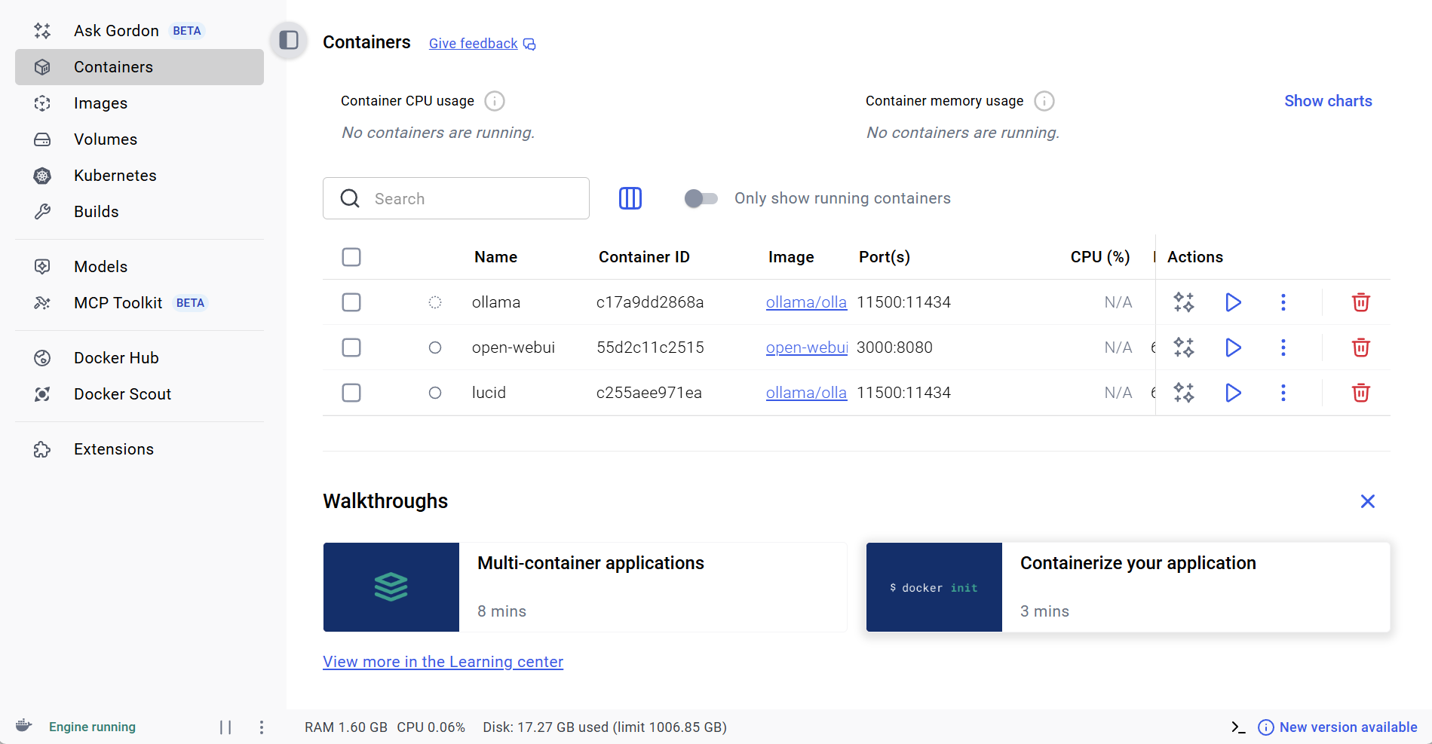
You can check the containers on docker to ensure you have the correct configurations
Once you have found out your IP address (Ipconfig in Command Prompt):
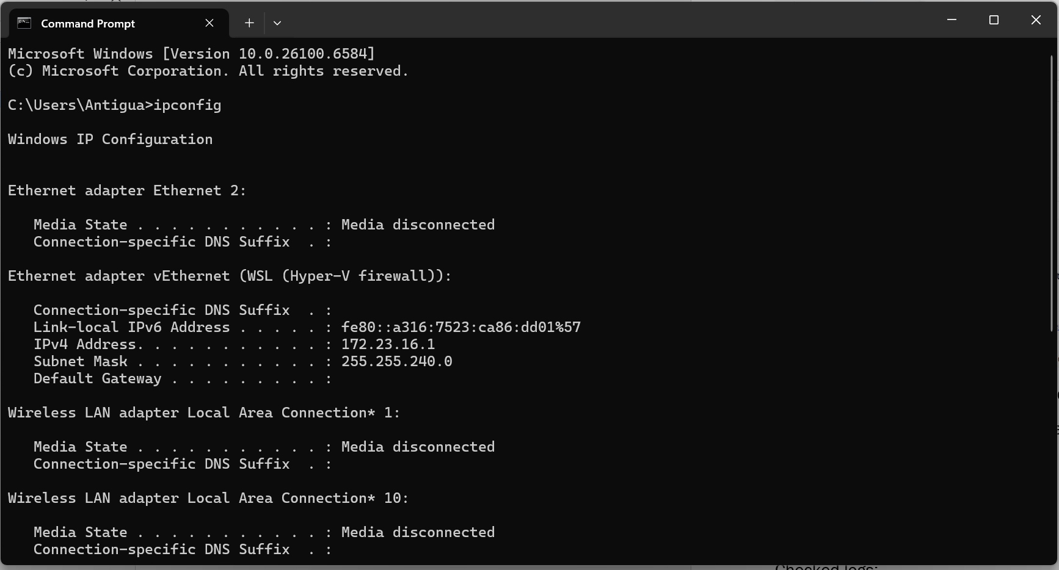
Connect another device to the same network. Go to any web browser on the secondary device. Type in the IP address of the local host, 192.168.X.X, followed by :3000 (or whichever host port you choose to use)

Web interface should work

Problems:
Problem: Internal Server Error (500) – Open WebUI unreachable remotely.

Symptoms:
- Remote devices received HTTP 500 when accessing http://<host-ip>:3000.
- Host could run the WebUI locally; container status was "Up".

Investigation commands:
- docker logs -f open-webui
- docker rm -f open-webui
- docker run -d -p 3000:8080 --name open-webui ghcr.io/open-webui/open-webui:main
- docker restart open-webui
- ipconfig (on Windows host)
- ping <host-ip> (from client)
- curl -I http://<host-ip>:3000 (from client)

Root cause:
Client device not on the same local network or routing/firewall prevented inbound HTTP traffic to the host on port 3000. Once the client joined the same LAN, the WebUI became reachable.

Resolution:
1. Ensure container is running and port mapping is correct.
2. Ensure client and host are on the same network or inter-subnet routing is allowed.
3. Open inbound port 3000 on the host firewall if needed.
4. Rebuild/restart container as necessary.

Prevention:
- Document host IP and mapped port.
- Configure firewall and routing to allow authorized clients.
- Monitor container/application logs when performing remote access tests.
Could not access web UI from other device:
Connected to the same network, which fixed the problem.

Conclusion:
I learned to set up a AI engine that runs locally using Docker. Additionally, I developed a Web UI which enables web access to AI from other devices on the network. Ran into the internal server error, which was eventually fixed through connecting the devices to the same network

